PYTHON numbers

Numbers in Python

In python, there are three types of numbers:

* Int
* Float
* Complex

Like any variable, numerical variables are created when you assign some value to them;

INT

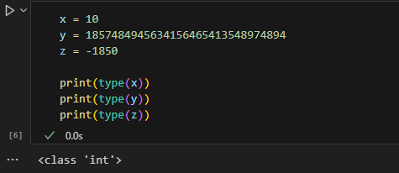Int or integer is an integer, positive or negative, without decimals, of unlimited size;

FLOAT

Float or 'floating point number' is a number, positive or negative, containing one or more decimal places;

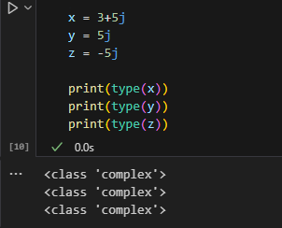COMPLEX

Complex numbers are written with "j" as an imaginary part;

Converting Types

You can convert one type to another using int(), float(), complex():

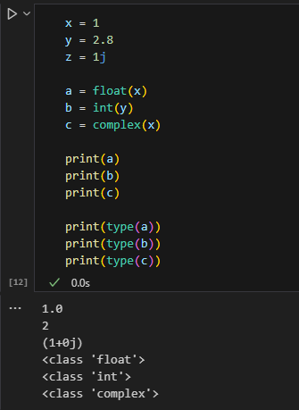You just can't convert complex numbers into another naked type

Random Number

Python doesn't have a random() function, but python has a built-in module called random that can be used to randomize;

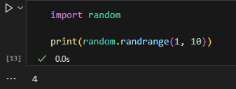

Meric